**RIPHAH INTERNATIONAL UNIVERSITY ISLAMABAD**



Assesment#1

Bachelors of Computer Science – 5th Semester

Subject: Operating System

Submitted to: Miss Kousar

Submitted by: Ayesha Akhter

Sap ID: 46508

**Lab Task**

**Q1.** To begin, you need to set up a structured directory layout in your home directory. Start by creating two directories named **OS_Course** and **OS_Lab**. These directories will serve as the main folders for organizing your OS Lab tasks. After creating these directories, switch to the **OS_Lab** directory. Within OS_Lab, create three more directories named **LAB_Class_Task, LAB_Activities, and Lab_Practice**. Each of these directories will help you categorize different aspects of your lab work. Once you have created these directories, go into the **Lab_Practice** directory and create a file named example.cpp. This file should be empty and will be used for practice later. Finally, move back to your home directory. Make sure to take screenshots of each step, including the creation of directories, the file creation, and your navigation commands to document your process.

**Note:** Include screenshots, where required to illustrate your explanation.

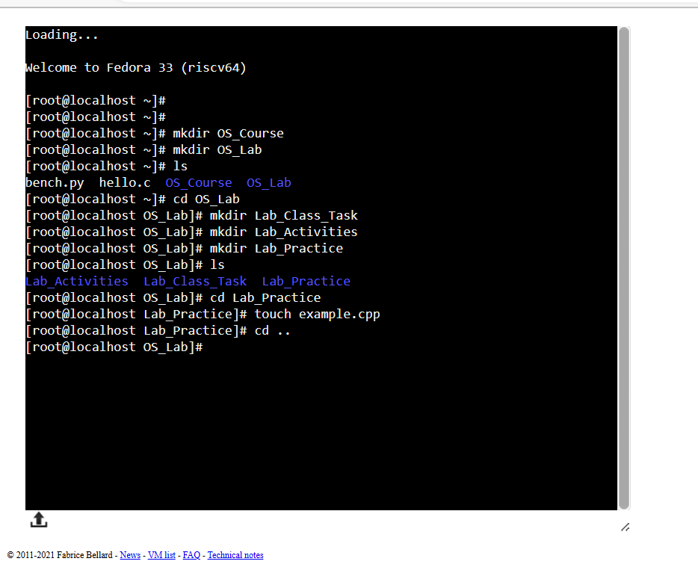

**Q2.** Finally, you need to understand the concepts of absolute and relative paths. Explain the difference between these two types of paths and provide an example of each. This will help you navigate directories more effectively. If you are currently in the Lab_Practice directory, describe the relative path to access the **LAB_Activities** directory. This will test your understanding of how to move between directories using relative paths.

**Note:** Include screenshots, where required to illustrate your explanation.

**Absolute Path**: An absolute path is a complete location of a directory in a system starting from the root directory.

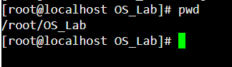

**Relative Path**: A relative path is a directory that starts from the current location in the system.



**Q3.** Imagine you’re working on your computer when you suddenly need to turn it off quickly. You press and hold the power button until the computer shuts down completely. After an hour, you turn the computer back on, and it quickly shows the login screen or desktop.

Why does your computer start up smoothly and quickly after being turned off? Describe the process that happens between powering off the computer and seeing the login or desktop screen. What steps does the computer go through to get everything ready in a short amount of time?

**ANS:**

* When we press the power button to turn on the computer then power supply sends power to mother board and other components inside the system unit.
* The computer performs the power-On self-test(POST), at this stage it checks the basic hardware components like CPU, ram and other storage devices to make sure they are working correctly.
* After post the system loads the boot loader from storage devices (such as hard drive or SSD). It is a small program that prepares the system to load the operating system.
* After that, the operating system kernel is loaded into memory and starts initializing system hardware and software components.
* Now, the operating system loads device drivers needed for the hardware components (e.g., graphics card, network adapter).
* Then, the operating system loads the graphical user interface (GUI). Depending on our operating system, we may see a login screen if use the password.

**Why it started quickly?**

* Modern computers often use SSDs (Solid State Drives) which have faster read and write speeds as compared to traditional HDDs (Hard Disk Drives). This speeds up the boot process.
* Efficient bootloaders and operating system optimizations can significantly reduce boot times.
* Operating systems cache certain data in RAM, which speeds up access to frequently used files and settings.